CAB230 – WEB COMPUTING

Assignment 2

Student 1: n9506420 Ian Maskell

Student 2: Cameron Short

Preferred Application: Chrome

**Home Screen Testing – Part A**

**Part E – Adding a Review**

When a user is in the item page they have the option to post a review if they are logged in. If they are not logged in then the Add Review button is disabled and selecting it will show a prompt explaining that the user must log in. An example is shown below.

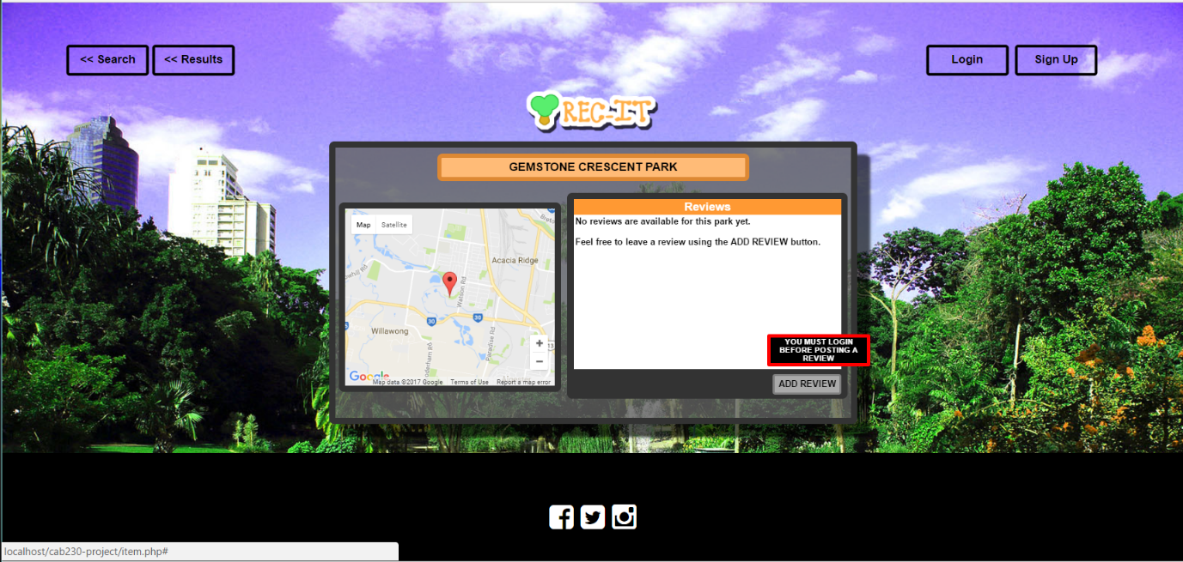

However when a user selects the ADD review button when logged in a fixed overlay is displayed which is used to add a review. As shown below.

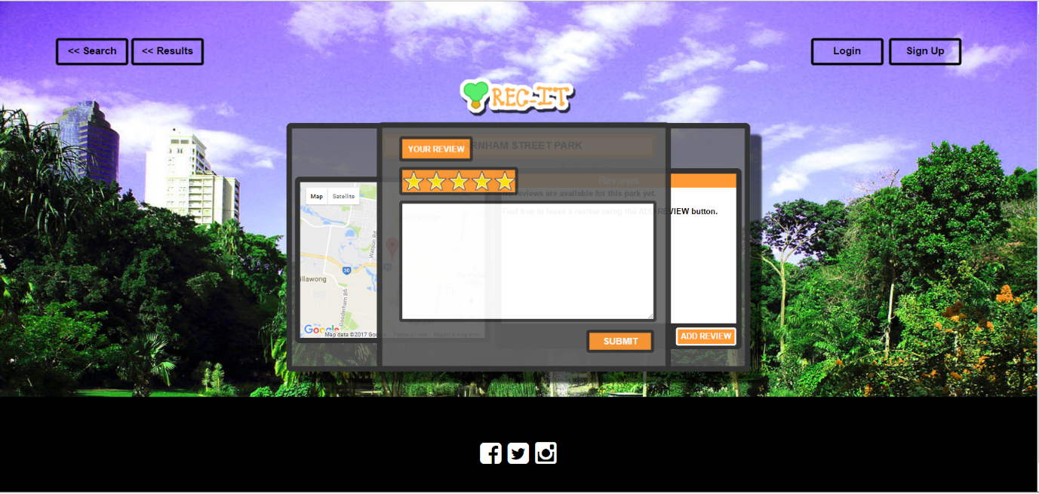

The post review overlay only has two components the user can select for their review, the star rating (which by default is 5), and the text field. The text field must be over 20 words, this is to prevent empty reviews. An example is shown below.

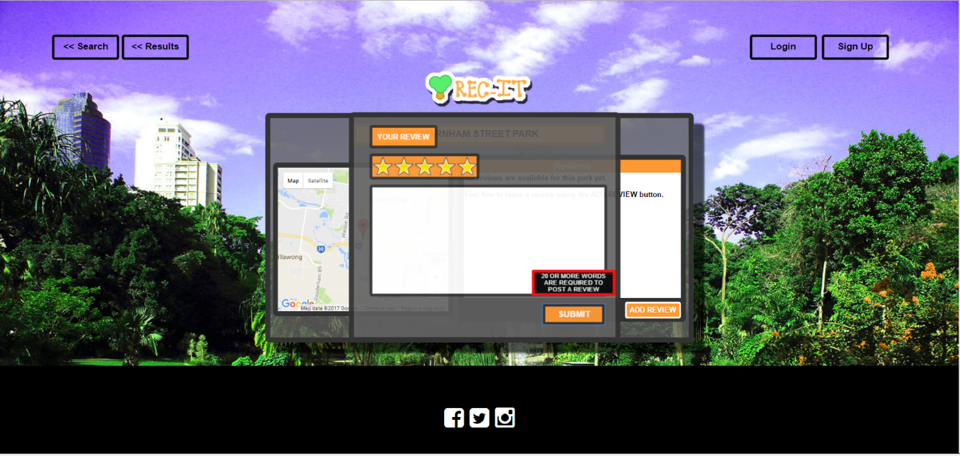

When the post complies with the requirement the page is directed to a page that confirms that the post has succeeded. After 2 seconds the page returns back to the item page the user was originally viewing with the included review.



**F – Searching for an item that exists in the database**

The only input that needs validation on the Search (Home) page is the text input by the user in the search box. When the page loads two arrays are created in JS from information retrieved from PHP via SQL query. A HTML datalist element is created from the two arrays. After 3 characters are entered remaining possible matches will display in a dropdown box. As shown below.

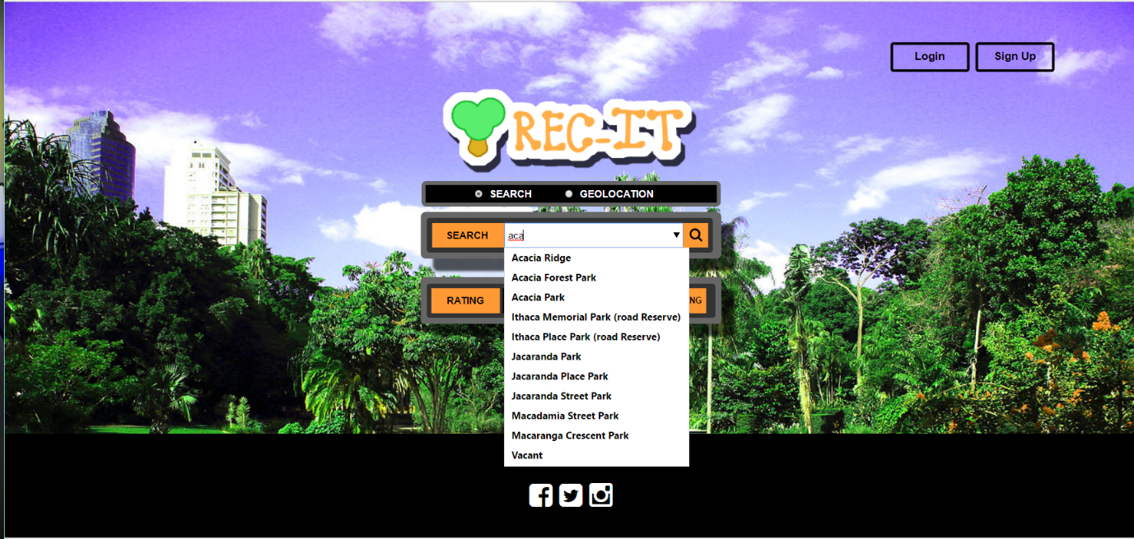

If the user was to select Acacia Ridge they are directed to the results page with results that match the suburb. As shown below.

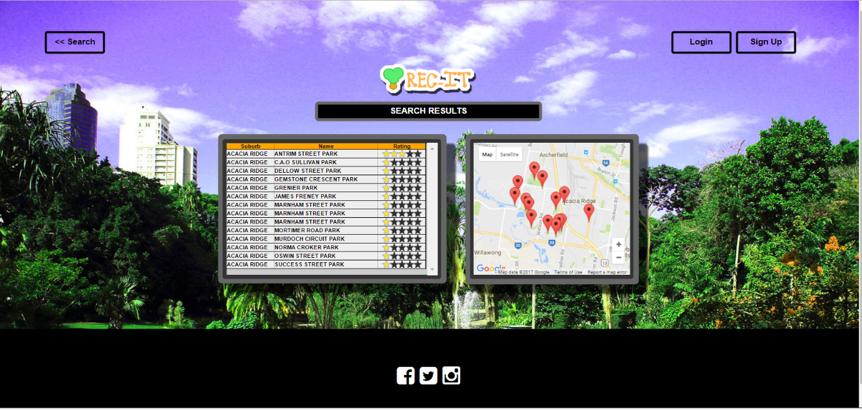

**G. Searching for an item that does not exist in the database**

Any input that does not match a datalist entry receives an Invalid search location in the search input bar and they are unable to continue until a valid Suburb or Park Name is entered. In the example below a user puts in a query that does not match any existing suburb or parkname.

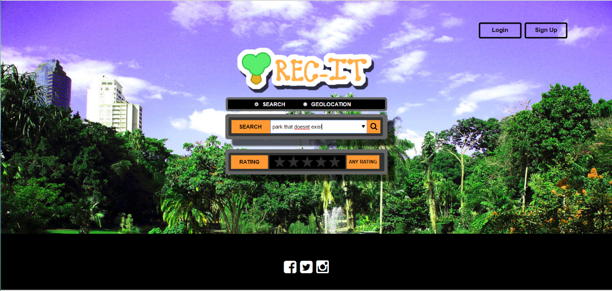

The search input box alerts the user to the issue.



**H. Individual Search Item Page**

From the results page the user can select either the park map pin (which displays the name of each park when hovered) or the park from the list of results. In the test below the user selects ‘Antrim Street Park’.

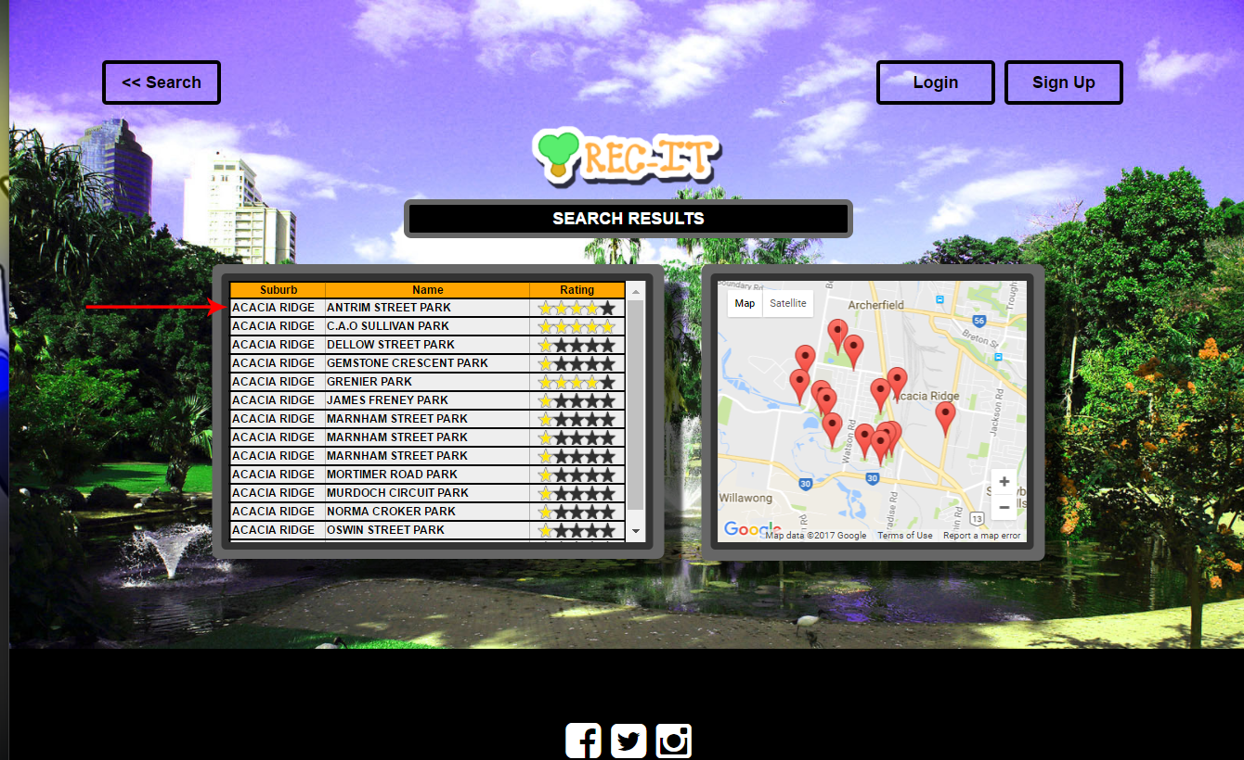

From here the item page for the selected park is displayed. A map with the individual park location is displayed on the left and the reviews on the right. It also allows the user to write their own review when logged in.

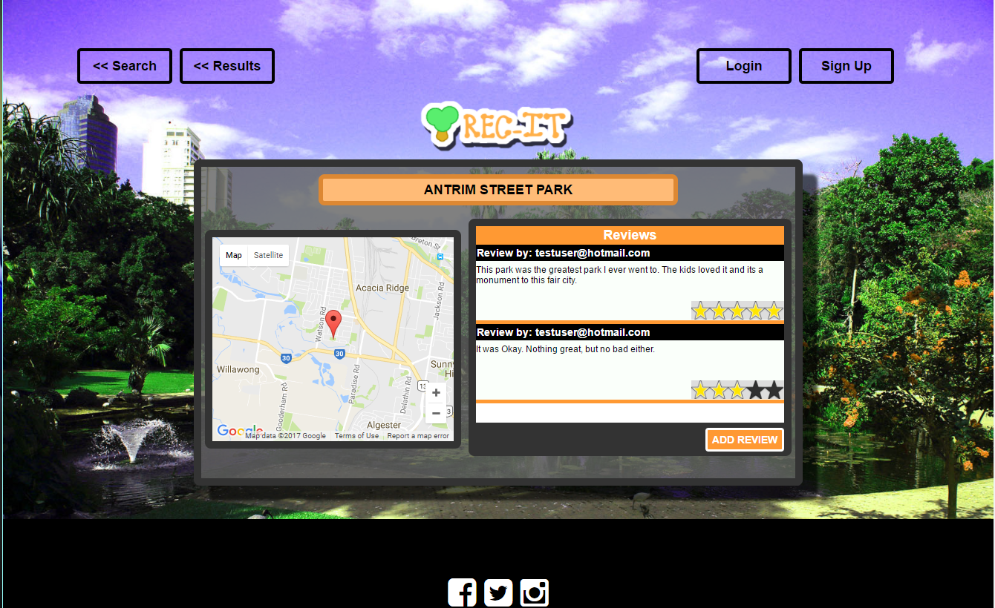

**I. Attempting to Use a cross site scripting attack but not being successful**

In the search page html I injected a script to show an alert to display the document cookies.

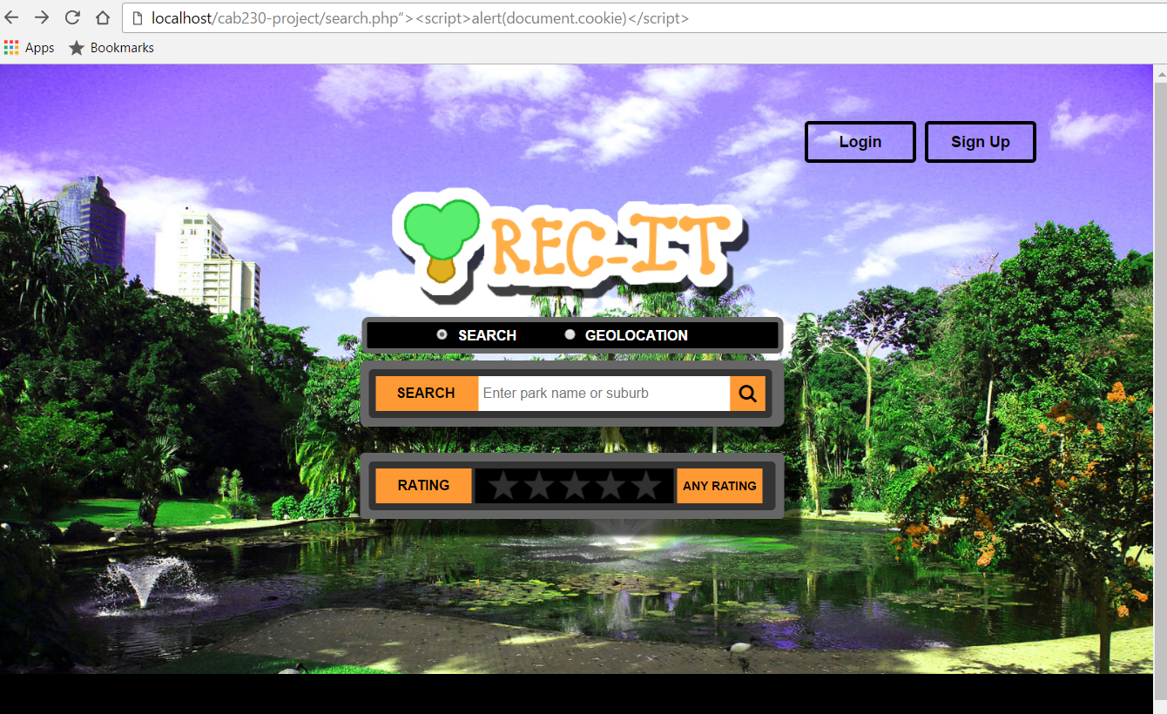

The result is blocked by the server as the user doesn’t have permission to access html with the injected code.

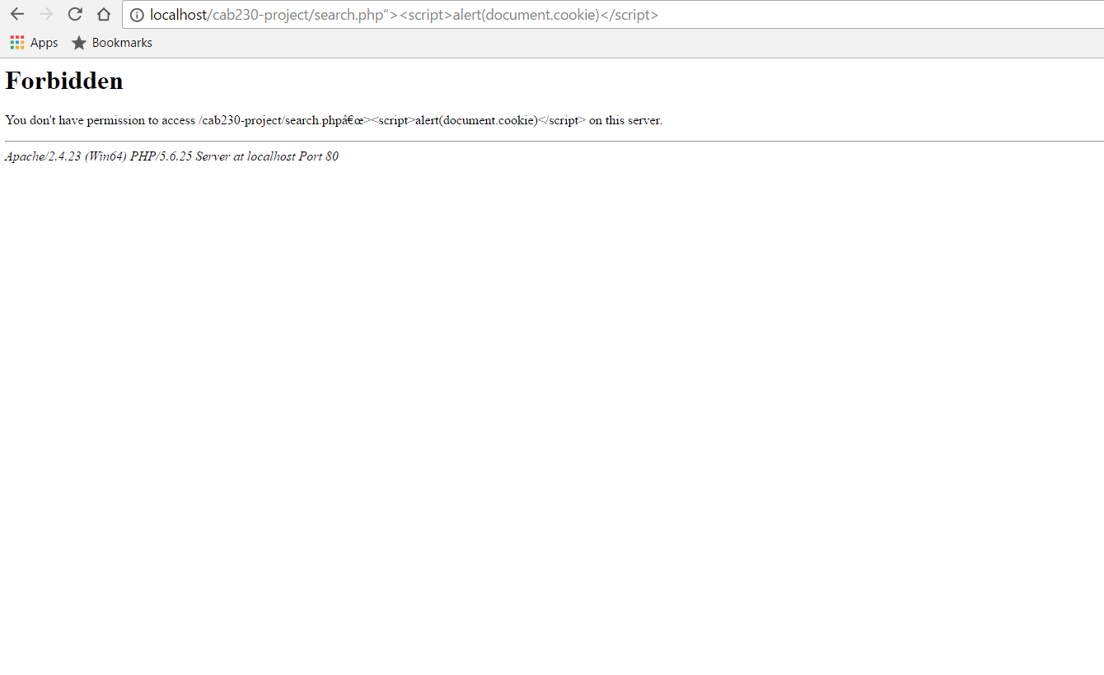

**I. Attempting to Use a cross site scripting attack but not being successful**